Miranda Pachini
MSBA 692 Pipelines to Insights

1. Project Title
Green Thumbs & Runny Noses: A Forecasting Tool for Gardeners with Allergies
A hybrid environmental insights dashboard powered by an end-to-end Extract-Transform-Load (ETL) pipeline.

2. Introduction / Background
In Kentucky, spring brings two things without fail: beautiful gardens and terrible allergies. For many in Kentuckiana-myself included-the decision to step outside depends on a delicate balance between soil temperatures, frost risk, pollen levels, and whether the air will make their eyes water.
Traditional Weather apps offer pieces of this puzzle, but none provide a combined, personalized view that helps people decide:
- Is today a good day to plant tomatoes?
- Is it safe to work in the yard without triggering allergies?
- Which days this week are the best for outdoor activities?
This project builds a complete data engineering pipeline that transforms raw environmental data from the Open-Meteo API into a fun, intuitive, and genuinely useful dashboard. By combining pollen, air quality, soil conditions, and weather forecasts, the dashboard helps Kentuckians breathe easier and garden smarter.
3. Problem Statement
People with allergies are also people who love to garden and need a data-driven way to evaluate outdoor conditions. Existing tools provide fragmented information, making it difficult to identify:
- High risk allergy days
- The best planting windows
- Weather patterns that affect both comfort and plant health
Problem Statement:
There is no automated pipeline that integrates pollen, air quality, soil conditions, and weather forecasts into a single, personalized dashboard that supports outdoor decision making for allergy prone gardeners.

4. Objectives (Specific Aims)
- Extract pollen, air quality, soil, and weather data from the Open-Meteo API using python.
- Transform and clean JSON data into structured tables with standardized timestamps and units.
- Load processed data in a CSV format.
- Engineer Metrics:
  - Allergy Risk Score
  - Planting Readiness Score
  - Outdoor Comfort Score
  - Best Day Flags
- Build an interactive dashboard in Power BI:
  - Activity Type Slicer
  - Plant Type Slicer
  - Allergy Sensitivity Level Slicer
  - Best Days Only Slicer
- Deliver a reproducible ETL workflow that can be refreshed to update the dashboard.

5. Methodology / Technical Approach
Data Source
Open-Meteo API endpoints used:
- Pollen Forecast (Trees, Grass, Ragweed)
- Air Quality (PM2.5, PM10, Ozone)
- Soil Conditions (Soil Temperature, Soil Moisture)
- Weather Forecast (Temperature, Precipitation, Frost Risk, Wind, Solar Radiation)
Tools and technologies
- Python (requests, pandas, datetime)
- CSV
- Microsoft Power BI for visualization
- Modular ETL script (Extract-Transform-Load Design)
ETL workflow design
Extract:
- Pull data from each Open-Meteo endpoint for Louisville coordinates.
- Save raw JSON for validation and reproducibility.
Transform:
- Convert JSON into pandas Data Frames
- Clean and Standardize timestamps, units, and missing values.
- Engineer Metrics:
  - Allergy Risk Score (pollen +PM2.5 +wind +humidity)
  - Planting Readiness Score (soil temperature+ frost risk +rainfall +sunlight)
  - Outdoor Comfort Score
  - Best Days Flags
- Categorize pollen levels (Low, Moderate, High)
Load:
- Export cleaned tables to CSV.
- Organize by Category: Pollen, Soil, Weather, Combined Metrics.

Dashboard & Visualizations Strategy
Core Visuals
- 7-day allergy risk forecast
- 7-day planting readiness forecast
- Soil temperature trend
- Pollen +Wind interaction chart
- Daily KPIs (hottest day, frost risk, highest pollen day)
Wow-Factor Slicers
- Activity Type Slicer
  - Adjusts comfort thresholds for gardening, exercise, dog walking, lawn care, etc.
- Plant Type Slicer
  - Applies plant specific soil temperature and frost sensitivity rules.
- Sensitivity Level Slicer
  - Personalizes allergy risk scoring low to severe sensitivity.
- Best Days Only Slicer
  - Filters to show only the tip recommended days for planting or low-allergy outdoor activities.
Example Workflow: ETL Architecture Diagram (Described)
- Open-Meteo-API
- Python ETL Script
- Cleaned CSV Storage
- Power BI Dashboard
- User Slicers and Insights

6. Timeline
Week | Tasks
Week 1 | Research endpoints, finalize scope, draft proposal, design ETL architecture.
Week 2 | Build API extraction scripts, parse JSON, create initial Data Frames and transformation pipeline
Week 3 | Complete data cleaning, engineer metrics, finalize storage structure (CSV).
Week 4 | Build Power BI dashboard, implement slicers, create visualizations, and KPIs.
Week 5 | Final testing, run full pipeline, refine dashboard, prepare presentation and final documentation.

7. Expected Outcomes
- A fully functional ETL pipeline that extracts, transforms, and loads multi endpoint environmental data.
- A structured dataset containing pollen, air quality, soil conditions, weather forecasts, and metrics.
- A polished, interactive Power BI dashboard featuring:
  - Activity Type Slicer
  - Plant Type Slicer
  - Sensitivity Level Slicer
  - Best Days Only Slicer
- A recommendation engine identifying the best planting days and lowest allergy risk days.
- A final presentation demonstrating pipeline design, dashboard functionality, and key insights.
8. Data Dictionary  Variable | Type | Description | Threshold / Logic
planting_readiness | Float (0–100) | Composite score estimating suitability for planting based on soil temperature, soil moisture, wind, and precipitation probability. | Weighted formula (40% soil temp, 20% rain, 20% wind, 20% soil moisture).
allergy_risk | Float (0–100) | Composite score estimating allergy burden based on PM2.5, ozone, and average pollen concentration. | Weighted formula (25% PM2.5, 15% ozone, 60% pollen).
best_overall_day_flag | Binary | Indicates whether the day is optimal for outdoor activity considering planting, allergies, wind, rain, and air quality. | Planting ≥ 65, Allergy ≤ 40, no rain, no high wind, AQI ≤ 100.
high_wind_flag | Binary | Indicates whether wind speeds exceed safe thresholds for planting or outdoor work. | wind_speed_10m > 15 mph
rain_expected_flag | Binary | Indicates whether rain probability is high enough to disrupt planting or outdoor activity. | precipitation_probability > 50%
soil_too_wet_flag | Binary | Indicates whether soil moisture is too high for planting or equipment use. | soil_moisture_0_to_1cm > 0.35
poor_air_quality_flag | Binary | Indicates whether AQI exceeds EPA threshold for sensitive groups. | us_aqi > 100
high_pollen_flag | Binary | Indicates whether average pollen concentration is high enough to trigger allergy symptoms. | mean pollen > 150 grains/m³
heat_stress_flag | Binary | Indicates whether temperatures exceed OSHA caution thresholds for heat stress. | temperature_2m ≥ 85°F
respiratory_risk_flag | Binary | Indicates elevated respiratory burden due to combined pollutants and pollen. | allergy_risk ≥ 60

9. Flag Summary Table
Flag | Meaning | Interpretation
high_wind_flag | Wind > 15 mph | Unsafe for planting, spraying, or sensitive outdoor work.
rain_expected_flag | Rain probability > 50% | Outdoor activities should be delayed; poor planting conditions.
soil_too_wet_flag | Soil moisture > 0.35 | Soil compaction risk; avoid planting or equipment use.
poor_air_quality_flag | AQI > 100 | Unhealthy for sensitive groups; limit outdoor exposure.
high_pollen_flag | Avg pollen > 150 | High allergy burden; avoid prolonged outdoor exposure.
heat_stress_flag | Temp ≥ 85°F | Heat caution; limit strenuous outdoor work.
respiratory_risk_flag | Allergy risk ≥ 60 | Elevated respiratory burden from pollutants + pollen.
best_overall_day_flag | Composite of planting + allergy + weather | Indicates the best days for outdoor activity or gardening.
10. 🌼 DATABASE SCHEMA DOCUMENTATION
dim_datetime
Column | Type | Description
datetime_id (PK) | SERIAL | Surrogate key
timestamp_local | TIMESTAMP | Local timestamp
year | INT | Year
month | INT | Month
day | INT | Day
hour | INT | Hour
weekday | VARCHAR | Day of week
dim_environmental_factors
Column | Type | Description
env_id (PK) | SERIAL | Surrogate key
latitude | FLOAT | Latitude of location
longitude | FLOAT | Longitude of location
location_name | VARCHAR | Human-readable location
fact_environmental_conditions
Column | Type | Description
fact_id (PK) | SERIAL | Surrogate key
datetime_id (FK) | INT | Links to dim_datetime
env_id (FK) | INT | Links to dim_environmental_factors
temperature_2m | FLOAT | Temperature
wind_speed_10m | FLOAT | Wind speed
precipitation_probability | FLOAT | Rain probability
soil_temperature_0cm | FLOAT | Soil temp
soil_moisture_0_to_1cm | FLOAT | Soil moisture
pm25 | FLOAT | PM2.5
ozone | FLOAT | Ozone
us_aqi | FLOAT | AQI
grass_pollen | FLOAT | Pollen
ragweed_pollen | FLOAT | Pollen
birch_pollen | FLOAT | Pollen
alder_pollen | FLOAT | Pollen
mugwort_pollen | FLOAT | Pollen
olive_pollen | FLOAT | Pollen
planting_readiness | FLOAT | Composite score
allergy_risk | FLOAT | Composite score
high_wind_flag | INT | 0/1
rain_expected_flag | INT | 0/1
soil_too_wet_flag | INT | 0/1
poor_air_quality_flag | INT | 0/1
high_pollen_flag | INT | 0/1
heat_stress_flag | INT | 0/1
respiratory_risk_flag | INT | 0/1
best_overall_day_flag | INT | 0/1
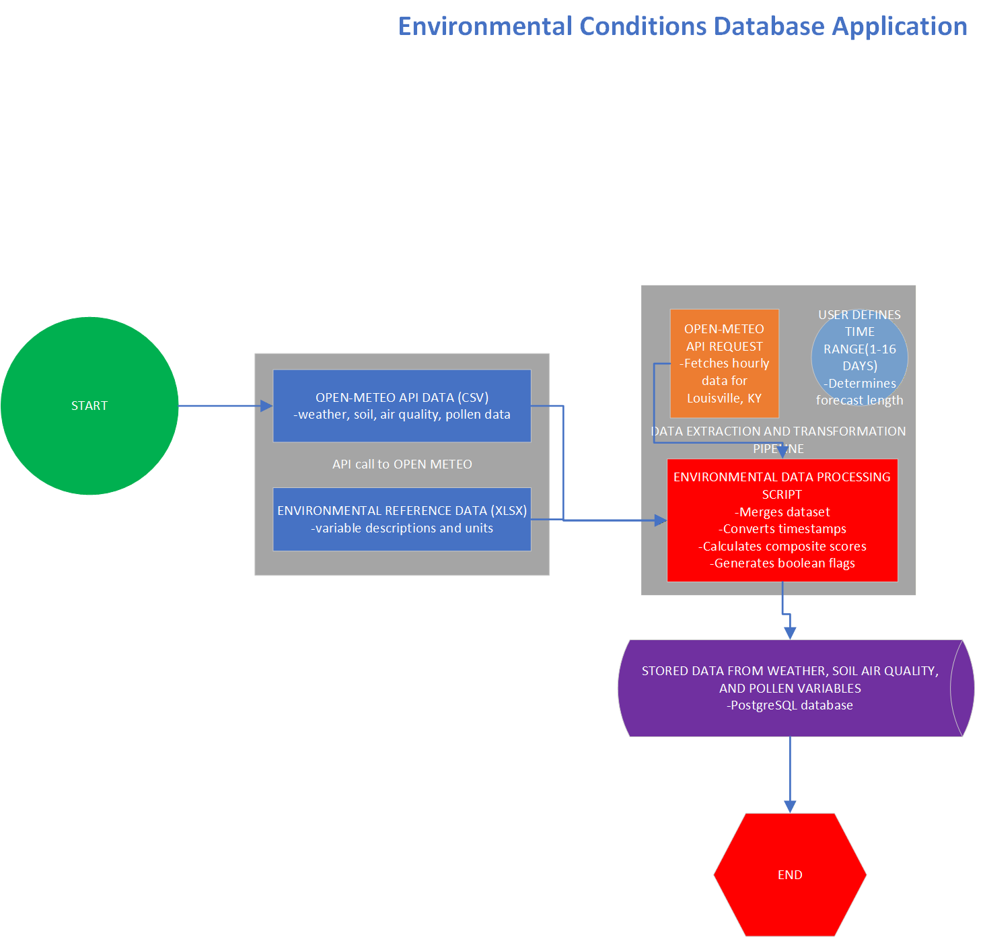
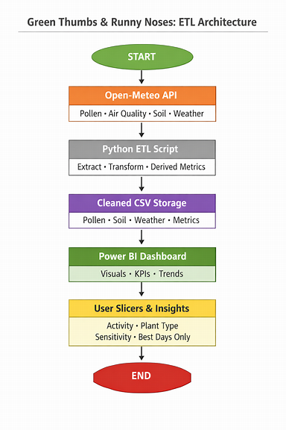
Resources:
Open-Meteo API
Open-Meteo. (2026). Open-Meteo weather, air quality, and environmental forecast APIs. https://open-meteo.com
Lecture Slides
Simms, M. (2026). MSBA 692: Pipelines to insights [PowerPoint slides]. University of Louisville, College of Business, Department of Analytics & Information Systems. (Available through Blackboard course site.)
Proposal Template
University of Louisville, College of Business. (2026). MSBA project proposal template [Course document]. (Available through Blackboard → MSBA 692 → Course Documents.)
Microsoft Copilot
Microsoft. (2026). Microsoft Copilot help & learning. https://support.microsoft.com/copilot
Visual architecture diagram for this proposal was generated using Microsoft Copilot.

